REPORT

*A report submitted in partial fulfilment of the requirements for the Award of Degree of*

## BACHELOR OF TECHNOLOGY

**in**

## INFORMATION SCIENCE AND ENGINEERING

**By**

**SANTHWANA K SURESH - 1NT21IS141**

**N PADMA PRIYA - 1NT21IS095**

**HANSITHA C - 1NT21IS060**

**Under Supervision of**

**Mrs. Akshatha Ullal Nayak**

## Nitte Meenakshi Institute of Technology

## Bangalore

**(Duration: 27th December, 2022 to 15th January, 2023)**



## DEPARTMENT OF INFORMATION SCIENCE AND ENGINEERING

## NITTE MEENAKSHI INSTITUTE OF TECHNOLOGY

(An Autonomous Institution)

Approved by AICTE, Affiliated to VTU, Belagavi

## Yelahanka, Bengaluru, Karnataka

## 2022 – 2023

**DEPARTMENT OF INFORMATION SCIENCE** **AND ENGINEERING**

**NITTE MEENAKSHI INSTITUTE OF TECHNOLOGY**

(An Autonomous Institution)

KARNATAKA



***CERTIFICATE***

This is to certify that the “**Program Elective report”** submitted by **SANTHWANA K SURESH (USN: 1NT21IS141), N PADMA PRIYA (USN: INT21IS095)** and **HANSITHA C (USN: INT21IS060)** is the work done by them and submitted during 2022 – 2023 academic year, in partial fulfilment of the requirements for the award of the degree of **BACHELOR OF TECHNOLOGY in INFORMATION SCIENCE AND ENGINEERING,** at **Nitte Meenakshi Institute of Technology.**

|  |  |  |
| --- | --- | --- |
| **Mrs. Akshatha Ullal Nayak**  **Web Technology (PE),**  **Department of ISE** |  | **Dr. Mohan S G**  **Head of the Department,**  **Department of ISE** |

# **ABSTRACT**

A website is an important medium for businesses that want to connect to its customers through online interface. Website building and maintaining is a combined process of development, testing and deployment. It takes a good amount of man power and capital to give the customers an amazing user experience. Having a website is not only about features but also about adding and subtracting required functionality based on the customer feedback time to time. Fast changing IT industry with everyday coming of new tools is making it possible for businesses to offer better user experience, easier management, better functionality, etc. In this project, the focus was to redesign the website of HMT, in which we solve the problems related to the design of the page when a user opens the website. The number of pictures used to describe the products available at the store, making it easy for customers to contact the company in the required location through one of the available stores and making the website more user friendly and attractive which leaves a positive impact on customers.

**SANTHWANA K SURESH (INT21IS141)**

**N PADMA PRIYA (1NT21IS095)**

**HANSITHA C (1NT21IS060)**

# **ACKNOWLEDGEMENT**

It is indeed with a great sense of pleasure and immense sense of gratitude that I acknowledge the help of these individuals.

I am highly indebted to Dean **Dr. V. Sridhar** and Principal **Dr. H.C. Nagaraj,** for the facilities provided to accomplish this program elective.

I would like to thank my Head of the Department **Dr. Mohan S G** for his constructive criticism throughout my semester.

I would like to thank **Mrs. Akshatha Ullal Nayak,** web technology professor Department of ISE for her support to complete this program elective. Your useful advice and suggestions were really helpful to me during the project’s completion. In this aspect, I am eternally grateful to you.

I am extremely grateful to my department staff members and friends who helped me in successful completion of this course.

**SANTHWANA K SURESH (INT21IS141)**

**N PADMA PRIYA (1NT21IS095)**

**HANSITHA C (1NT21IS060)**

**TABLE OF CONENT**

|  |  |  |  |
| --- | --- | --- | --- |
| **S. No.** | **Content** |  | **Page No.** |
| 1. | Introduction |  | 6 |
| 2. | Problem Statement |  | 8 |
| 3. | Literature Review |  | 14 |
| 4. | Tools Used |  | 19 |
| 5. | Improvements |  | 21 |
| 6. | References |  | 30 |

**INTRODUCTION**

Web technology is a method of communication, unique to computers through the use of binary codes and directions. As it is known that computers don't communicate with each other the way people do. Instead, computers require codes, or directions. These binary codes and commands allow computers to process needed information. Every second, billions upon billions of ones and zeros are processed in order to provide us with the information we need.

The methods by which computers communicate with each other through the use of markup languages and multimedia packages is known as **web technology**. In the past few decades, web technology has undergone a dramatic transition, from a few marked-up web pages to the ability to do very specific work on a network without interruption. The below fig.1 and fig. 2 shows how the internet websites and search engines have transition from simple to glamorous.

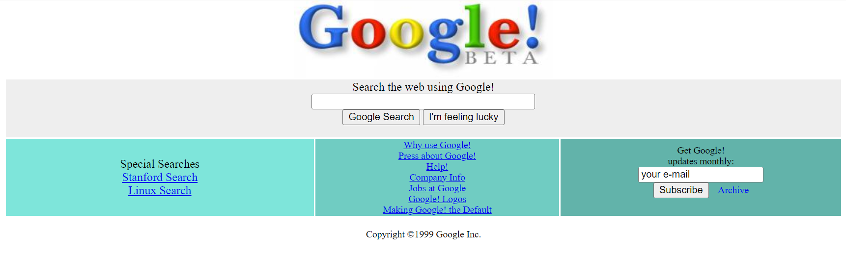

**Fig. 1:** Google in 1999

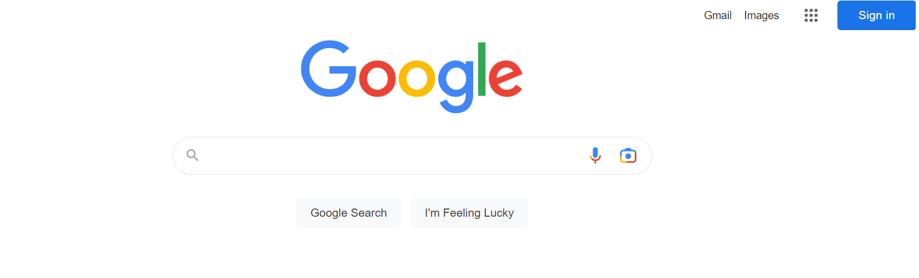

**Fig. 2:** Google in 2023

Internet usage has increased tremendously and rapidly in the past decade. Websites have become the most important public communication portal for most, if not all, businesses and organizations. According to a report published by [Internet and Mobile Association of India (IAMAI)](https://www.livemint.com/news/india/rural-india-has-20-more-internet-users-than-urban-areas-nielsen-11651812524529.html) [1] says at present, there are a total of 692 million active internet users in India, including 351 million from rural India and 341 from urban Indian. The report estimates that there will be 900 million internet users in India by 2025.

As business-to-consumer interactions mainly occur online, website design is critical in engaging users. Poorly designed websites may frustrate users and result in a high “bounce rate”, or people visiting the entrance page without exploring other pages within the site. On the other hand, a well-designed website with high usability has been found to positively influence visitor retention (revisit rates) and purchasing behavior.

Little research, however, has been conducted to define the specific elements that constitute effective website design. One of the key design measures is usability ([International Standardization Organization, 1998](https://www.ncbi.nlm.nih.gov/pmc/articles/PMC4974011/#R24)). The International Standardized Organization (ISO) defines usability as the extent to which users can achieve desired tasks (e.g., access desired information or place a purchase) with effectiveness (completeness and accuracy of the task), efficiency (time spent on the task), and satisfaction (user experience) within a system.

In present time the most useful programming languages and tools available to create a desirable website depend upon which part of development is required. Backend development includes the process of using programming languages and frameworks to facilitate the development of robust systems for web applications. Web development activities at the backend of programs are referred to as backend development. It covers server-side web application logic and integration activities, like writing APIs, creating libraries, and working with system components, unlike frontend development. While there are many different programming languages, the most common ones used in web development are JavaScript, HTML, CSS, PHP, etc. JavaScript has a popularity of nearly 65% among developers worldwide, as per [Statista](https://www.statista.com/statistics/793628/worldwide-developer-survey-most-used-languages/) [2].

**PROBLEM STATEMENT**

To redesign a website for “HMT WATCHES” [3]. E-commerce provides an easy way to sell products to a large customer base. However, there is a lot of competition among multiple e-commerce sites.

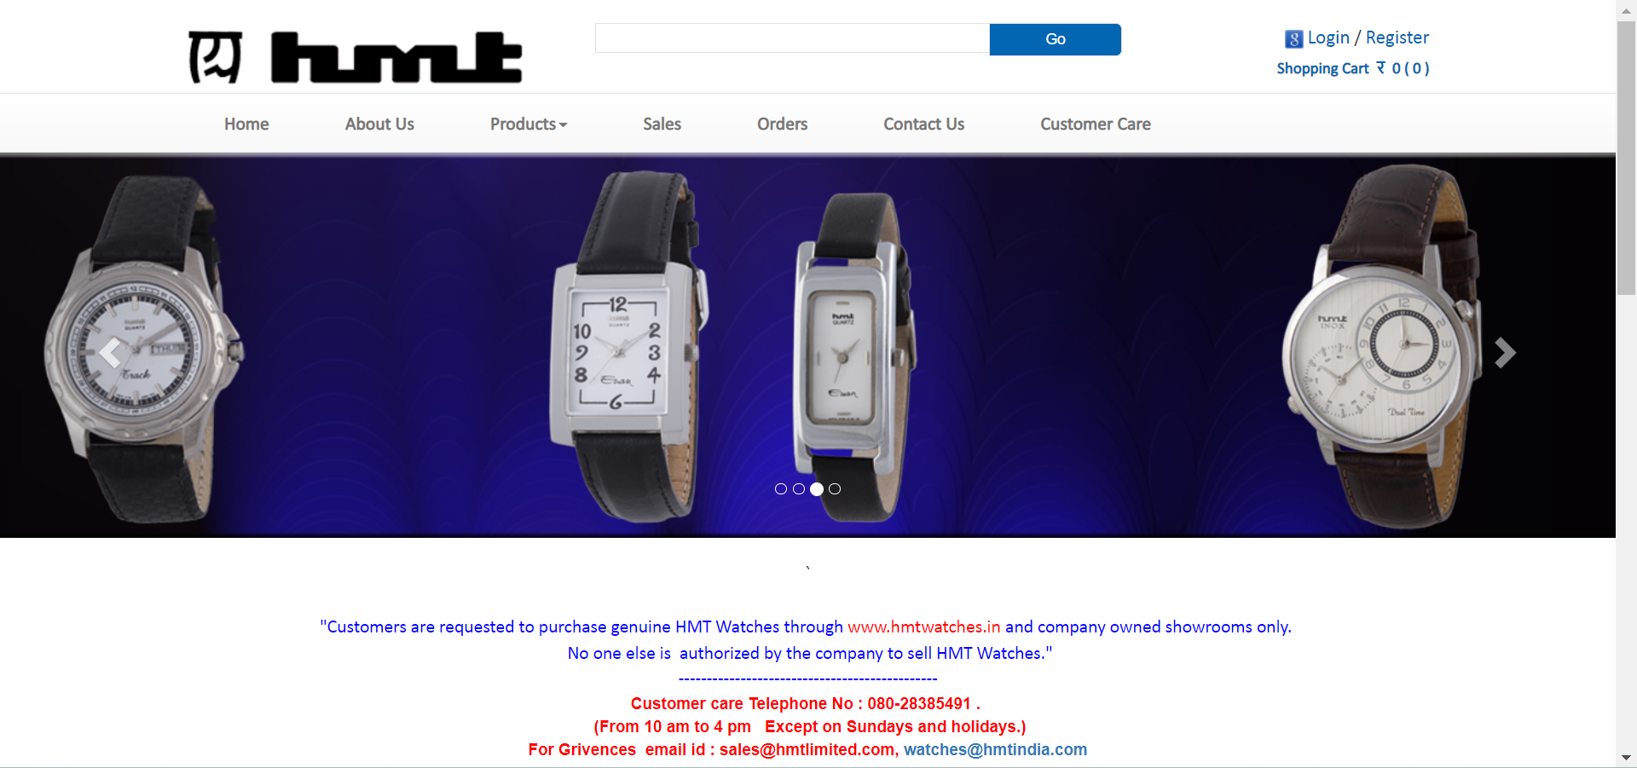

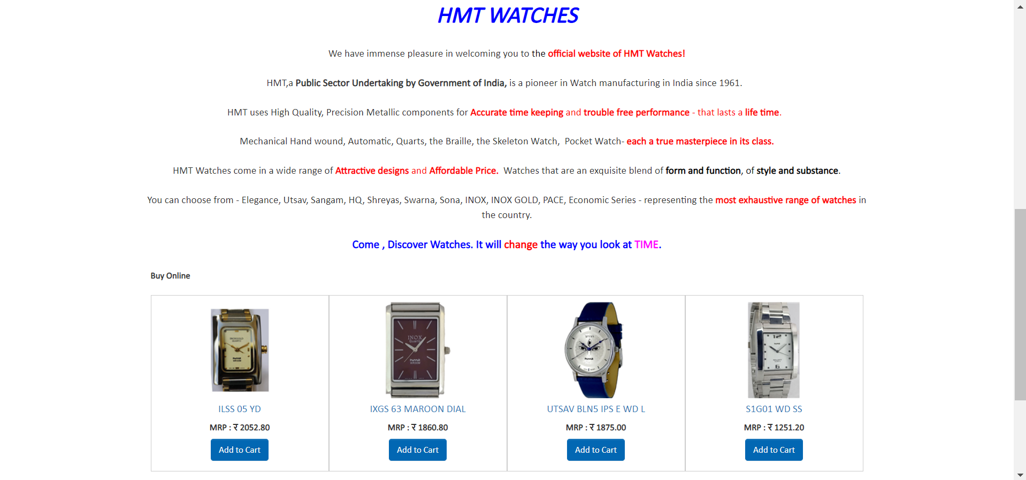



**Objective:** To redesign an interactive website for the brand through thorough research on existing websites and analyzing the flaws in the current website of the brand.

**Create an Engaging Website Design:**

1. **Keep the layout simple:**

The simpler your website layout, the better. That doesn’t mean it has to be boring, but it does mean it should focus on the essentials. Clean, functional layouts make your site easier to load, navigate, and use on different platforms and devices.

1. **Make navigation easy to follow:**

If you want visitors to spend time on your site, you need to make it easy for them to get around. It may be tempting to do something creative with your navigation menus design, but the simplicity and intuitive information architecture are more important. Make your menus standard in appearance helps your readers feel comfortable as they move throughout your site.

1. **Use clear calls to action:**

What is it that you’d like site visitors to do? Buy products? Sign up for an email newsletter? Donate to a cause? Think about your calls to action. Design them in a way that makes them stand out to a visitor scanning your website. If you’re using buttons in your design, make sure the text is short and direct.

1. **With content, less is more:**

Use what you know about your visitors to minimize their options and focus their attention on your products. Show only the text and visual elements that you want them to take action on. Websites for mobile apps like Pocket do a great job with this. They focus on explaining the app, include strong calls to action to install it. Less important content, like their About section and their blog are less prominent and are linked in the footer.

1. **Don’t be afraid of whitespace:**

White space is simply empty space on a page. It doesn’t have to actually be white it just has to contain no text or images. If done well, it can improve readability and remove clutter from your website design. White space can also help direct focus and attention. It provides a way to separate features and ideas so that visitors can discern exactly what you want them to see in a quick glance, rather than having to visually sort through a noisy and crowded layout. Google is the ultimate example of utilizing whitespace. It couldn’t be cleaner just a blank page with a logo and a search box.

1. **Enhance your website design with eye-catching colors:**

Pick a color that will provide the foundation of your entire website design, and then choose a contrasting accent color for important buttons and other interface elements. You can learn more about choosing the right color palette for your brand. Whole Foods Market uses green for their primary brand color, and the little pops of the secondary orange draw the eye toward featured calls to action.

1. **Incorporate attractive, easy-to-read fonts:**

Use an attractive type that is visually balanced and unique to make your website text clear and intriguing. Four top trending fonts are Brandon Grotesque, Museo Sans, Railway, and Playfair Display.

1. **Engage users with video and rich images:**

Videos and images are more engaging than text alone—in fact, landing pages with videos can boost conversions by more than 80%. Use scalable images (SVG) to ensure a high-quality user experience on both desktop and mobile devices. Nonprofit charity: water displays a video on their homepage, making it one of the first things you see when you visit their website for maximum impact.

**Improvement Areas:**

1. **Logo Location:** The logo used in the website should either be placed at the right/left corner or at the center of the page.
2. **Search Bar:** The search bar should be shown as a magnifier at right top corner. This would provide aesthetics to the website and save space for other useful links.
3. **Content Alignment and Color Code:** The overall theme and color code looks unorganized and misaligned with respect to the current trends in websites.
4. **Need of a Chat box:** A help chat box is required for immediate guidance to the customers running shot of time.
5. **Product Images:** Products are not shown with fascinating and attractive images to lure the customers. It rather gives a boring and outdated look of the product.
6. **Buy Button:**  A direct buy button is missing rather only an add to cart button is available.
7. **Footer:** Footer is missing an updated copy right warning with leads to the vulnerability of the content available on the website.
8. **Offers, Sale and Alert Notification System:** Offers, sales and notification are the most useful ways among all the marketing techniques to derive the traffic on the website and also to increase the sale of the products. This feature is completely void in this website.
9. **Categorization of Product:** The categorization of product for example men, women, kids and sport watches is not found anywhere in the website with leaves the customer in a fix of category confusion, ultimately leading to the change of mind about the purchase.
10. **Guarantee, Return and Shipping Details:** A section providing information related to guarantee of the product, shipping details of the product upon ordering and return in case of faulty product gives assurance to the customer of not losing his money. Addition of such information along with the product is must but, missing here.
11. **App Link and Social Media Links:** With the coming up of android phones, mobile apps are a new norm for customers ease to buy the product from anywhere. Social media pages of brands to create awareness about their products are new features of websites. Such links are completely absent from this website.
12. **Wishlist:** A great feature to short list a product for buying later should be added in the website as customer also prefer to wishlist their choices as this saves their time in product search when they revisit the website.
13. **Nearby Stores:** This feature helps those customers who prefer to buy products offline without taking the risk of return. Thus, currently every general brand uses this feature and so should this website be using it.

**LITERATURE REVIEW**

**Top Navigation Bar:**



* A website’s navigation bar is often the first touchpoint visitors interact with to guide them to specific products or categories.
* The navigation bar is very plain and there is no proper alignment.
* The navigation bar is not sticky and hence the users have to scroll back to the top of the page to access it again.
* The search bar is not aligned with the logo.
* The login and register elements can be styled and aligned better.
* The choice of colors is very dull.

Here's another example of the brand- [**Sonata**](https://www.sonatawatches.in/)[4]



* A lot of content is dumped into the navigation bar. Content could have been grouped in a better fashion to make the nav bar look less cluttered.
* The contents on the top part of the navigation bar are poorly displayed.
* Alignment of the location and search bar needs to be improved.
* Details like the outline of the navigation bar (Content exceeding the outline) need to be taken care of.

**Layout:**

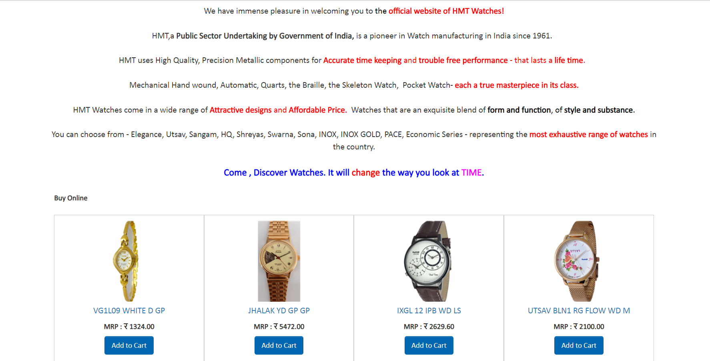

* A website layout is the arrangement of all visual elements on a webpage. Through the intentional positioning of page elements, we can control the relationship between them to better guide the user experience.
* The layout of the website is very tacky. It makes users uninterested in the site.
* The content is aligned in a haphazard manner.
* The background or lack of thereof, gives the website an unfinished look.
* The choice of font could have been better.
* The choice of colors used to highlight specific content needs to be improved.
* The display of products looks cluttered.

**Footer:**

**According to Neilsen Norman Group's discovery:**

The website footer is the section of content at the very bottom of a web page. It typically contains a copyright notice, link to a privacy policy, sitemap, logo, contact information, social media icons, and an email sign-up form.

We might be thinking that there's no point in putting a lot of time and effort into the page footer because people don't pay attention to content below the fold. This type of thinking is validated by most scroll behavior research, including the last major study performed by [Neilsen Norman Group](https://www.nngroup.com/articles/scrolling-and-attention/) in 2018. They found that 57% of page-viewing time was spent above the fold.

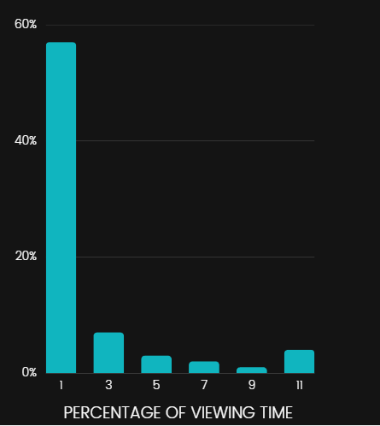

We will notice that despite Neilsen Norman Group's discovery that time spent viewing decreased the farther down the page, there's an uptick at the very end.

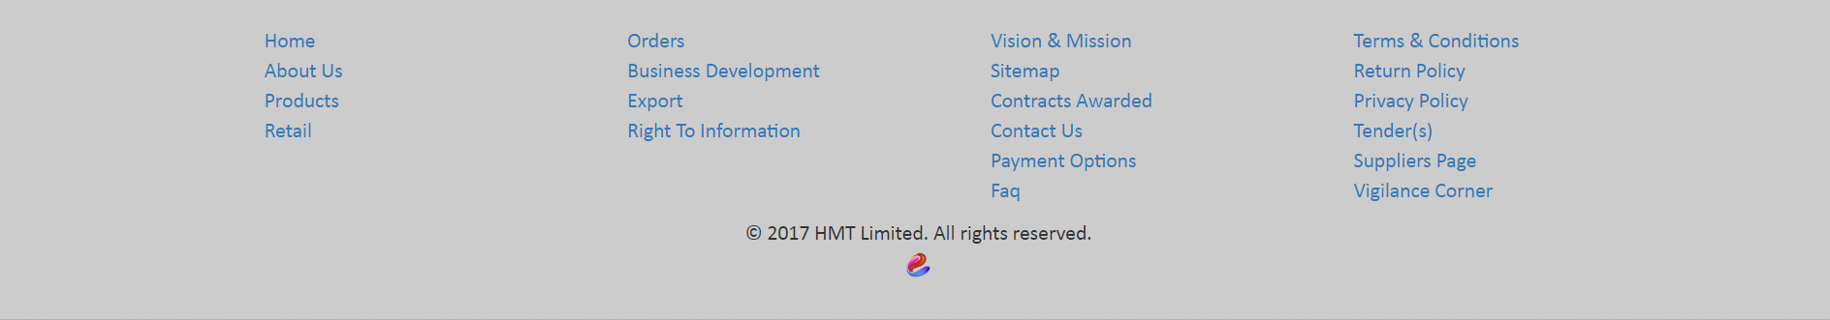

What to put in a footer?

1. Copyright Notice
2. Privacy Policy Link
3. Sitemap
4. Logo
5. Contact Information
6. Social Media Icons
7. Email Sign-up Form

* Any more information would make the footer look cluttered like the one on HMT's website.
* The choice of colors makes it hard to read the text.
* Lacks social media icons and links.
* Contents from the navigation bar are repeated. It can be avoided to give a cleaner look.

Here's the footer of another website of the brand - [**Smiths Watches**](https://www.smithswatches.com/)[4].

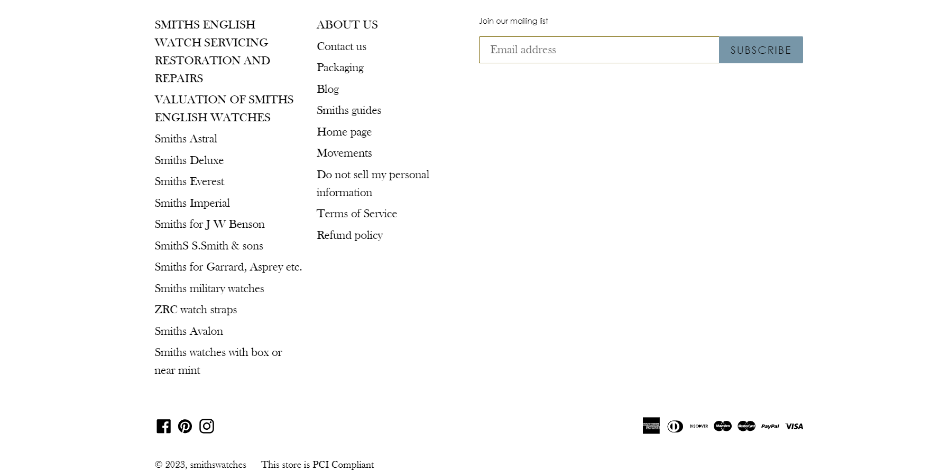

* The layout of the footer is very poor.
* Footer takes up the size of the webpage. It should be smaller with proper alignment of content.
* Lesser content should be placed in the footer to avoid clustered display.
* Font selection and color code needs to be improved.
* Contact information is missing.

**REGISTER / LOGIN:**

* A Registration form is used to register or create a new account for a new user for a website and a login form is used to enter the details of a registered user into their particular account or portal.
* The design of the form is very basic.
* The layout is cluttered and rustic.
* Choice of colors or lack of thereof brings down the overall look of the website.

**TOOLS USED**

* **HTML** (Hyper Text Markup Language) is used to describe how a web browser should display a text file retrieved from a web server. HTML defines how a page is displayed and is a derivative of SGML – Standard Generalised Markup Language which is a standard system (an ISO standard) used to specify document structure. HTML allows the developer of a web page to define hyperlinks between that document and any others that are required.

HTML 5 is the fifth and current version of HTML. It has improved the markup available for documents and has introduced application programming interfaces (API) and Document Object Model (DOM).

**Features:**

* It has introduced new multimedia features which supports both audio and video controls by using <audio> and <video> tags.
* There are new graphics elements including vector graphics and tags.
* Enrich semantic content by including <header> <footer>, <article>, <section> and <figure> are added.
* Drag and Drop- The user can grab an object and drag it further dropping it to a new location.
* Geo-location services- It helps to locate the geographical location of a client.
* Web storage facility which provides web application methods to store data on the web browser.
* Uses SQL database to store data offline.
* Allows drawing various shapes like triangle, rectangle, circle, etc.
* Capable of handling incorrect syntax.
* Easy DOCTYPE declaration i.e., <!doctype html>
* Easy character encoding i.e., <meta charset=”UTF-8″>
* **CSS** style sheet language that is used to describe the appearance and formatting of a web document which is written in a markup language. CSS enables you to keep separate the instructions related to the presentation of web content from the web content itself. This separation provides improved content accessibility, flexibility and style sharing for websites .

**CSS3:** CSS3 stands for Cascading Style Sheet level 3, which is the advanced version of CSS. It is used for structuring, styling, and formatting web pages. Several new features have been added to CSS3 and it is supported by all modern web browsers. The most important feature of CSS3 is the splitting of CSS standards into separate modules that are simpler to learn and use.

* **JavaScript** is an Object-Oriented scripting language that is used to design interactive websites. It is developed by Netscape and works in all major browsers such as internet explorer, Firefox, chrome, opera. Web developers can use JavaScript with HTML code to add dynamic content to their websites. JavaScript is an interpreted language implying JavaScript requires an interpreter to execute its code.

**IMPROVEMENTS**

**Navigation Bar:**

The Navigation bar is sorted to make it look spacious and clean with only important link list. This improvement will help the user to navigate to the desired pages .

Below is the code for the same along with the redesigned navigation UI image.

**Layout:**

The text in the layout has been decongested with interesting alignment which attracts the customers to read it and gather the information. Some beautiful themes and color combinations have been used to make it look stylish.

Below is the code for the same along with the redesigned navigation UI image.

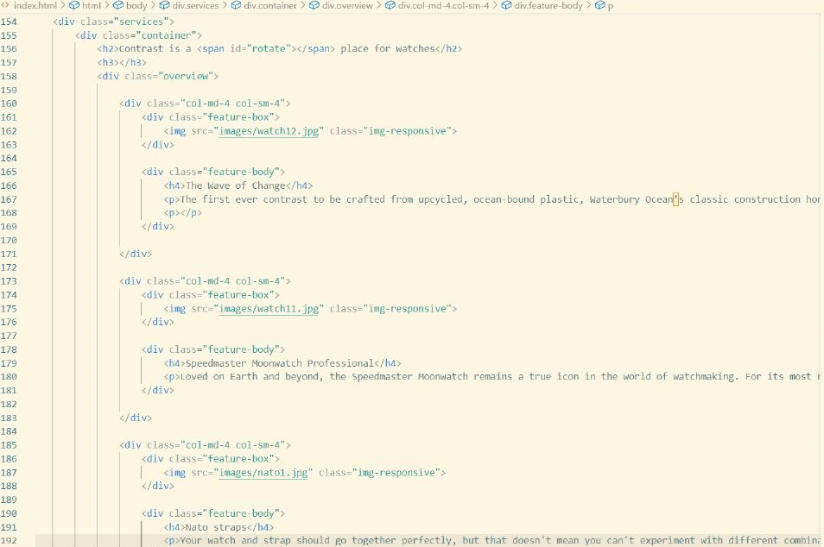

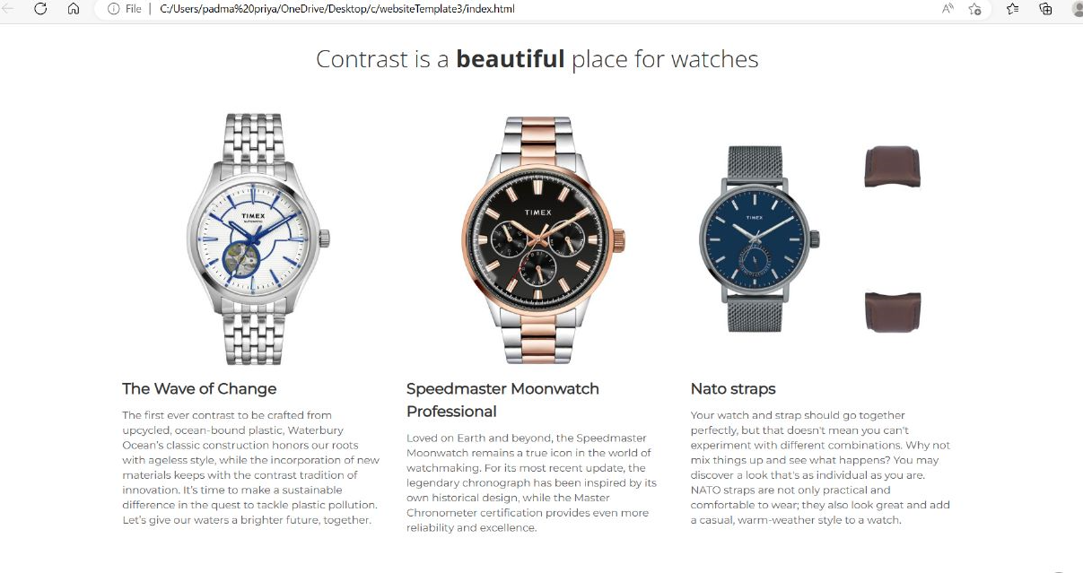

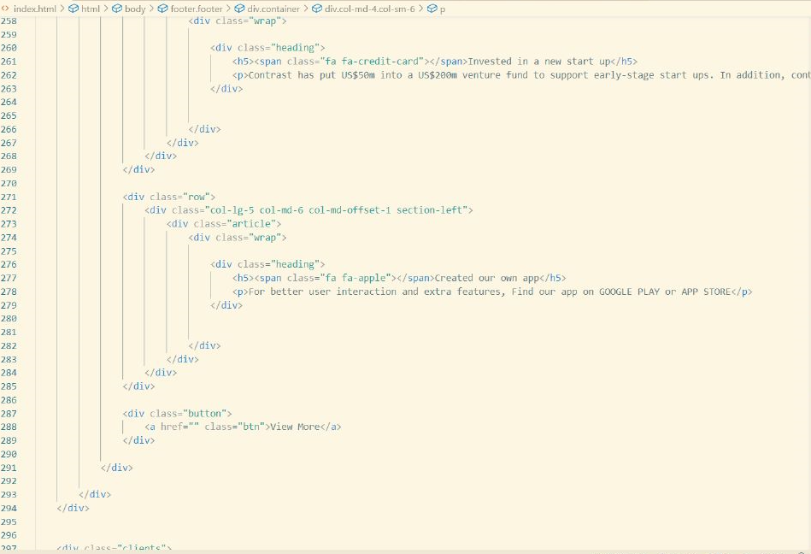

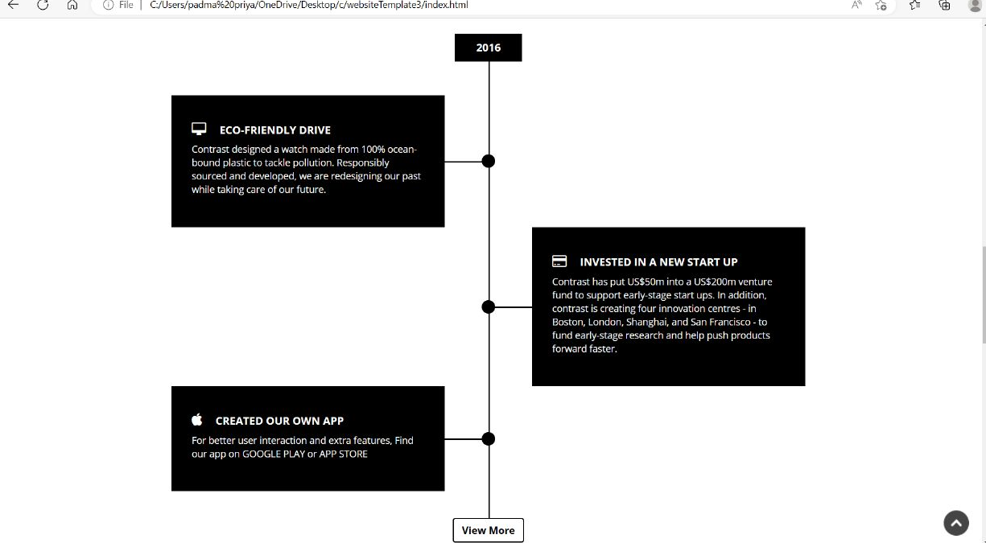

**Footer:**

The footer is made user friendly and easy to read . It contains all the necessary hyperlinks so that user can navigate to the different support systems. Social media links are also included along with contact information .

Below is the code for the same along with the redesigned navigation UI image.

**Login/Registration:**

Login and registration for users is easy to understand now and it promotes quick creation of accounts for new users also quick login for existing users.

Below is the code for the same along with the redesigned navigation UI image.

**Product Page:**

The product page is a page on a company website that showcases the product inventory a customer is able to buy. It helps customer decide what they want to buy according to different specifications.

Below is the code for the same along with the redesigned navigation UI image.

**REFERENCE**

[1] [www.iamai.com](http://www.iamai.com) and [https://www.livemint.com/news/india/rural-india-has-20-more-internet- users-than-urban-areas-nielsen-11651812524529.html](https://www.livemint.com/news/india/rural-india-has-20-more-internet-%20users-than-urban-areas-nielsen-11651812524529.html)

[2] [www.statista.com/https://www.statista.com/statistics/793628/worldwide-developer-survey-most-used-languages/](http://www.statista.com/https://www.statista.com/statistics/793628/worldwide-developer-survey-most-used-languages/)

[3] <https://www.hmtwatches.in/>

[4] <https://www.sonatawatches.in/>

[5] <https://www.smithswatches.com/>